Chapter 16, Problem 22.

Find the voltage across the capacitor as a function of time for t > 0 for the circuit in Fig. 16.45. Assume steady-state conditions exist at t = 0⁻.

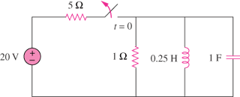

Figure 16.45
For Prob. 16.22.

